Experiment No.2: CDMA

PART A

(PART A: TO BE REFERRED BY STUDENTS)

  - Aim: To implement a basic function of Code Division Multiple Access (CDMA) to test the orthogonality and autocorrelation of a code to be used for CDMA operation. Write an application based on the above concept.

  - Prerequisite: Knowledge of multiplexing schemes

  - Objectives: To understand the importance of security in wirelesss communication by means of spread spectrum technologies.

  - Outcomes: Student will be able to articulate the knowledge of GSM, CDMA & Bluetooth technologies and demonstrate it.(LO-2)

Tools Used/programming language: Java

  - Theory:

    - Code-division multiple access (CDMA) is a channel access method used by various radio communication technologies. CDMA is an example of multiple accesses, where several transmitters can send information simultaneously over a single communication channel. This allows several users to share a band of frequencies (see bandwidth). To permit this without undue interference between the users, CDMA employs spread spectrum technology and a special codling’s scheme (where each transmitter is assigned a code).

CDMA issued as the access method in many mobile phone standards. IS-95,also called" cdma One", and its 3G evolution CDMA2000, are often simply referred to as "CDMA", but UMTS, the 3G standard used by GSM carriers, also uses "wideband CDMA", or W-CDMA, as well as TDCDMA and TD-SCDMA, as its radio technologies.

CDMA Orthogonality:
Techniques generally used are direct sequence spread spectrum modulation (DS-CDMA), frequency hopping or mixed CDMA detection (JDCDMA). Here, a signal is generated which extends over a wide bandwidth. A code called spreading code is used to perform this action. Using a group of codes, which are orthogonal to each other, it is possible to select a signal with a given code in the presence of many other signals with different orthogonal codes.

CDMA Autocorrelation:
Autocorrelation of the sequence, it determines the ability to synchronize and lock the spreading code for the received signal.

Procedure:

✔ The station encodes its data bit as follows.
- If bit = 1 then +1 o
If bit = 0 then -1

- no signal(interpreted as 0) if station is idle

✔ Each station is allocated a different orthogonal sequence (code) which is N bit long for N stations
✔ Each station does a scalar multiplication of its encoded data bit and code sequence.

✔ The resulting sequence is then stored on the channel.
✔ Since the channel is common, amplitudes add up and hence resultant channel sequence is the sum of sequences from all channels.

✔ If station 1 wants to listen to station 2, it multiplies (inner product) the channel sequence with code of station S2
✔ The inner product is then divided by N to get data bit transmitted from station 2.

Working
✔ CDMA uses orthogonal codes to transmit different signal over the same channel
✔ CDMA is use in 3’rd generation wireless communication like CDMA 2000, w-CDMA,HSDPA (high speed downlink packet access), HSUPA(high speed uplink packet access) ✔ CDMA stands for Code Division Multiple Access.

✔ It is a digital cellular standard that utilizes spread-Spectrum Technology.
✔ It spreads the signal over a fully available spectrum or over multiple channels through division.

✔ It is a more secure and private line.
✔ It has good voice and data communication capabilities.
✔ The information is sent simultaneously through several transmitters over a single communication channel.

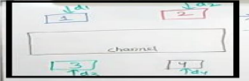
✔ Consider there is single channel having four users, user1,user2,user3,user4

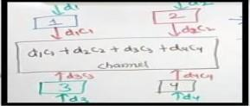
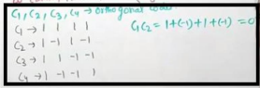
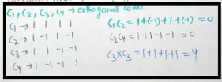
✔ Assume there are four orthogonal codes

✔ If two diff orthogonal codes are multiplied it will always give 0; this is the property of orthogonal code.

✔ User send data 1,0 (stream of data)or use may be silent that is no data to transmit.
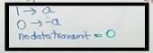
✔ Users are having following data
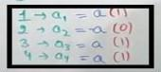
✔ Data in channel is;

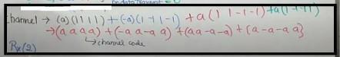
✔ If data 2 want to receive then R2= C(x)*C2

And hence we are getting –a after dividing by 4 and data send by user 2 is -a

Sample Output:
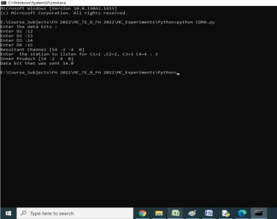

PART B

(PART B: TO BE COMPLETED BY STUDENTS)

(Students must submit the soft copy as per following segments within two hours of the practical. The soft copy must be uploaded on the ERP or emailed to the concerned lab in charge faculties at the end of the practical in case the there is no ERP access available)
Roll No. C-54 | Name: Quazi Md Moiuddin
Class : TE Comps C | Batch : C-3
Date of Experiment: 20.01.2025 | Date of Submission: 11.02.2025
Grade :

Question of Curiosity:

Q.1: Source Code (students need to implement CDMA using any programming language like Java, Python , etc)

import numpy as np

# Step 1: Input data bits for each user
print("***\nCDMA \n***\n")
z1 = int(input("Enter the D1 bit: ")) # Data bit for user 1
z2 = int(input("Enter the D2 bit: ")) # Data bit for user 2
z3 = int(input("Enter the D3 bit: ")) # Data bit for user 3
z4 = int(input("Enter the D4 bit: ")) # Data bit for user 4

# Step 2: Define the spreading codes (for simplicity, we use 4-bit codes)
c1 = [1, 1, 1, 1] # Code for user 1
c2 = [1, -1, 1, -1] # Code for user 2
c3 = [-1, 1, -1, 1] # Code for user 3
c4 = [-1, -1, 1, 1] # Code for user 4

# Step 3: Multiply the data bits with the corresponding spreading codes
r1 = np.multiply(c1, z1) # Transmitted signal for user 1
r2 = np.multiply(c2, z2) # Transmitted signal for user 2
r3 = np.multiply(c3, z3) # Transmitted signal for user 3
r4 = np.multiply(c4, z4) # Transmitted signal for user 4

# Step 4: Combine all the transmitted signals into the resultant channel
resultant_channel = r1 + r2 + r3 + r4
print("Resultant Channel: ", resultant_channel)

# Step 5: Let the receiver choose which channel to listen to
Channel = int(input("(Enter Digits as C1=1, C2=2, C3=3, C4=4)\nEnter the station to listen to: "))

# Step 6: Select the spreading code based on the chosen channel
if Channel == 1:
rc = c1
elif Channel == 2:
rc = c2
elif Channel == 3:
rc = c3
elif Channel == 4:
rc = c4
else:
print("Invalid channel selection!")
rc = None

# Step 7: If a valid channel was selected, calculate the inner product and decoded data bit
if rc is not None:
inner_product = np.multiply(resultant_channel, rc) # Calculate the inner product
print("Inner Product: ", inner_product)

res1 = sum(inner_product) # Sum the inner product to get the result
data = res1 / len(inner_product) # Normalize by the length of the code (to average it)

# Step 8: Print the decoded data bit
print("Data bit that was sent: ", round(data))

Q.2: Output of CDMA

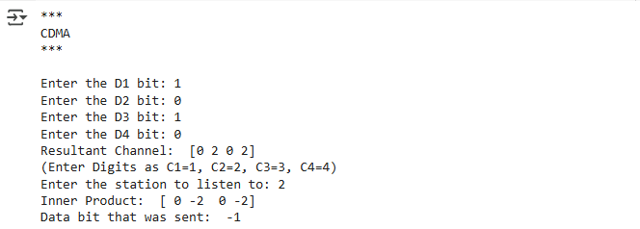

Q.3: Explain CDMA with one suitable example

CDMA, or Code Division Multiple Access, is a digital cellular technology that allows multiple users to share the same frequency band simultaneously. In CDMA, each user's signal is spread over a broad frequency spectrum using a unique code, and all users transmit their signals at the same time and on the same frequency. The receiver, equipped with the corresponding code, can then extract the intended signal from the mix of overlapping transmissions.
Example of CDMA multiple access: CDMA for three users A, B and C that transmit 0, 1 and 0, respectively. At the receiver, 1s will result in a positive weight, 8, equal to the length of the code, and 0s will produce the corresponding negative result, -8. The given codes, c A , c B and c C are orthogonal and perfect symbol recovery is possible in an ideal

Q.4: What is the spread spectrum? List types of spread spectrum technologies.
Spread spectrum is a communication technique used in wireless communication systems to spread the signal over a broader frequency band than the original signal bandwidth. This spreading of the signal helps in improving the reliability and security of the communication, as well as minimizing interference with other wireless systems.

There are two main types of spread spectrum techniques:
- Frequency Hopping Spread Spectrum (FHSS):
  - In FHSS, the transmitter and receiver hop between different frequencies in a predetermined sequence.
  - The hopping sequence is synchronized between the transmitter and receiver, and they switch frequencies at a very high rate.
  - This technique helps in minimizing the effects of narrowband interference.

- Direct Sequence Spread Spectrum (DSSS)
  - DSSS spreads the signal by multiplying it with a high-rate pseudo-random sequence, known as a spreading code.
  - The spreading code is also used by the receiver to despread the signal, allowing the original data to be recovered.
  - DSSS spreads the signal over a wider bandwidth compared to the original signal. Spread spectrum technologies can be further categorized based on their applications and variations

Q.5: Differentiate between FDM and FHSS.

FDM (Frequency Division Multiplexing) and FHSS (Frequency Hopping Spread Spectrum) are both techniques used in communication systems to transmit multiple signals over a shared medium, but they differ in their approach to achieving this goal.

- Frequency Division Multiplexing (FDM):
  - Concept:FDM involves dividing the available frequency bandwidth into multiple non overlapping frequency bands, with each band dedicated to a different communication channel. □ Usage: Each channel operates independently within its allocated frequency band, and multiple signals can be transmitted simultaneously without interference.
  - Implementation:FDM is commonly used in analog communication systems, such as traditional radio and television broadcasting
    - Advantages: Simple implementation, well-suited for analog signals, efficient use of bandwidth when channels have different data rates.
  - Frequency Hopping Spread Spectrum (FHSS):
    - Concept: FHSS involves rapidly changing the carrier frequency of the transmitted signal according to a specific hopping sequence known to both the transmitter and the receiver. □ Usage: The communication signal "hops" from one frequency to another in a predetermined pattern, and the receiver follows the same pattern to demodulate the signal.
    - Implementation:FHSS is commonly used in digital communication systems, such as wireless LANs and Bluetooth technology.
    - Advantages: Resistant to interference and jamming, provides security through frequency hopping patterns, efficient use of bandwidth.

Conclusion:

We are able to implement the Basic function CDMA) to test the orthogonality and autocorrelation of a code.

